Final Report

Mooncake Making Steps Step 1: Create the Mooncake Body In this step, we will create the basic shape of the mooncake, which is a cylinder. Code

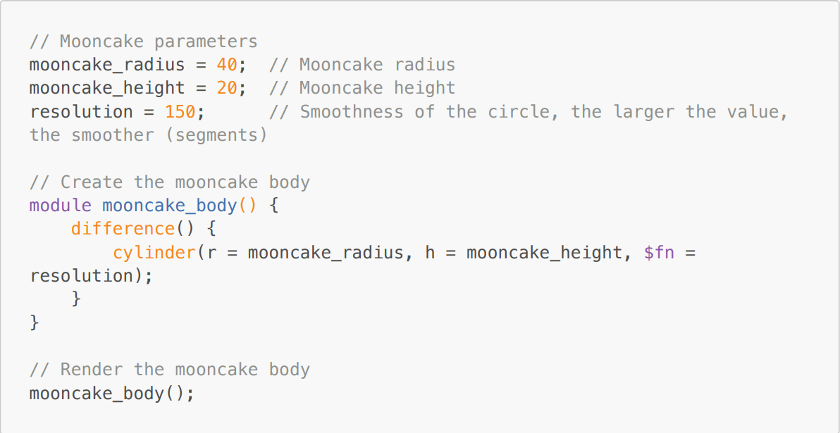

Image

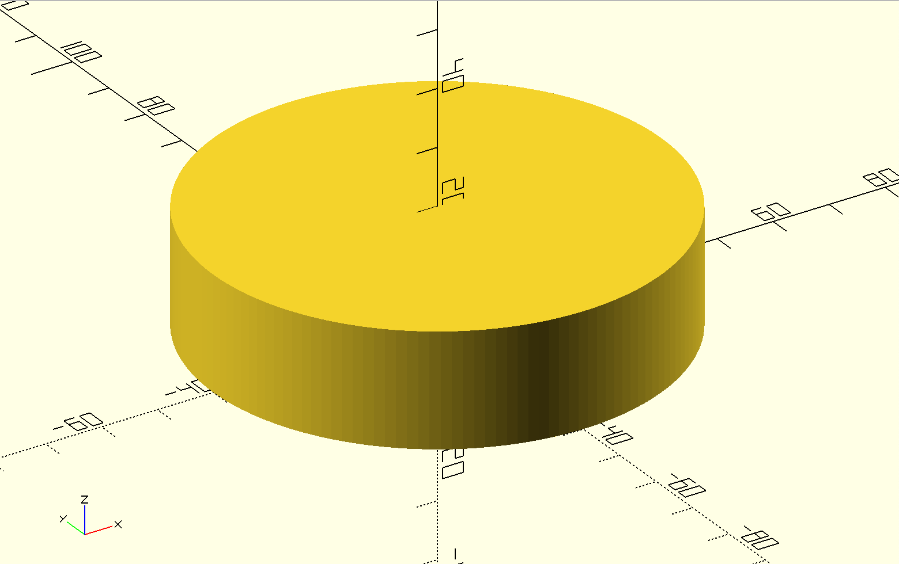

Step 2: Add Patterns

In this step, I will add vertical patterns to the mooncake body, making it more real

Code

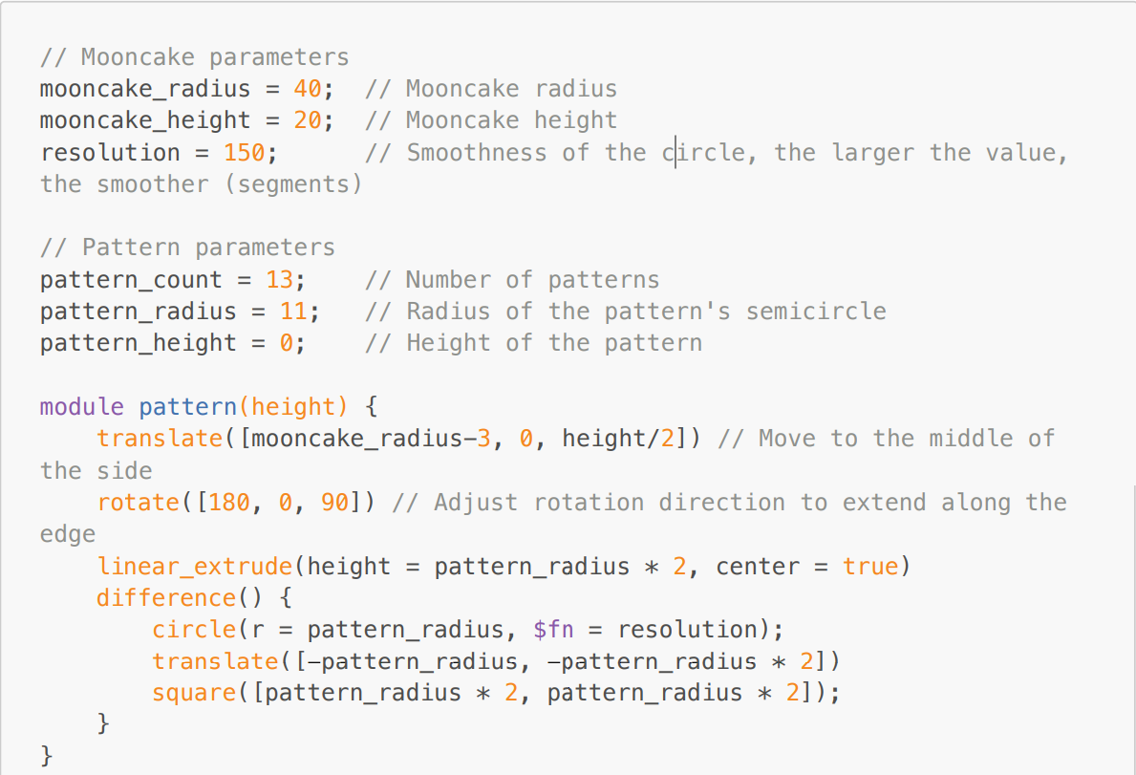

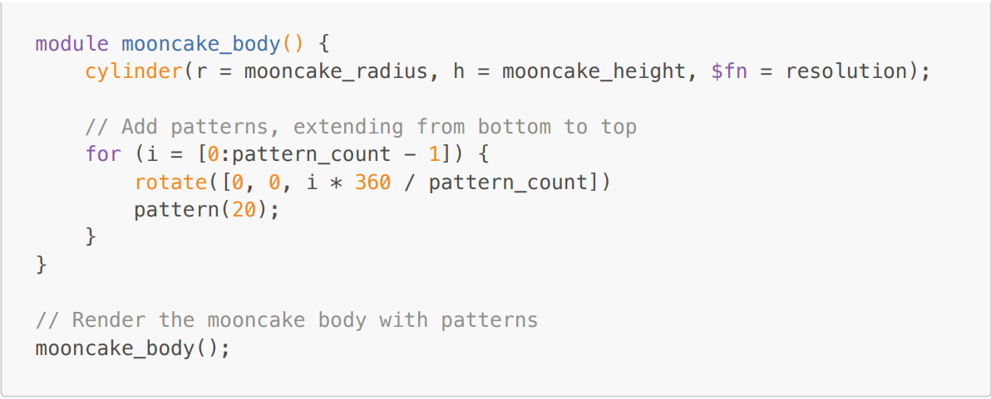

Explanation

In this step, we define a function called pattern that creates a pattern on the side of the mooncake. We then use a loop to add multiple patterns around the mooncake body. Image

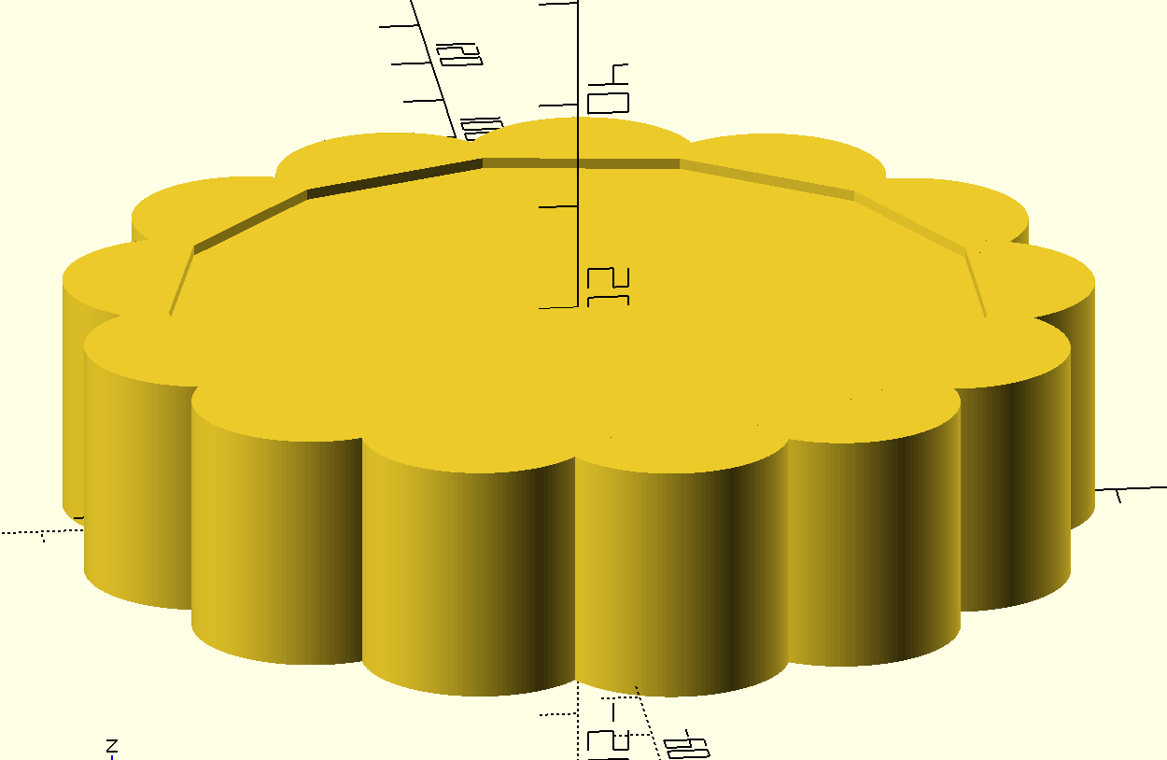

Step 3: Adding Top Patten

In this process, I create a circular truncated cone at the top of the cylinder. This function is like a stander for subsequent patten on mooncake, including text and TaiJi patten.

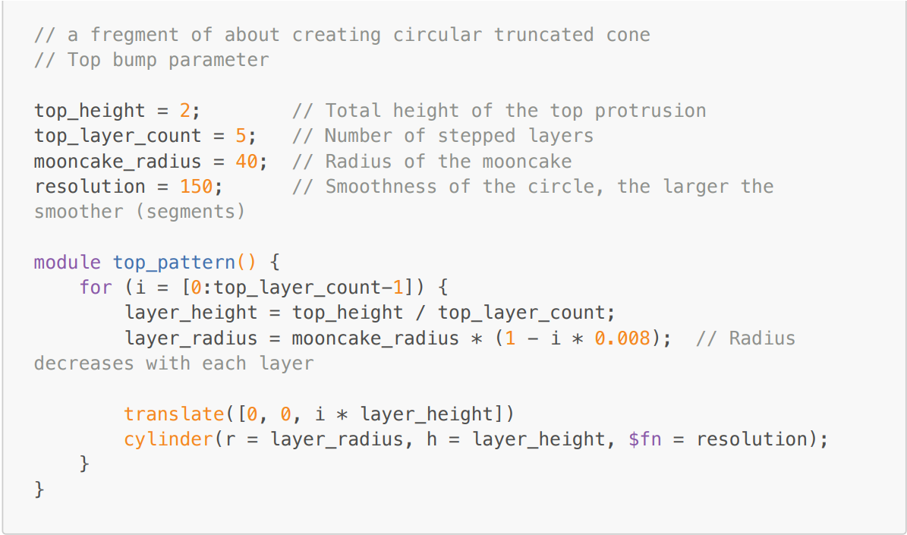

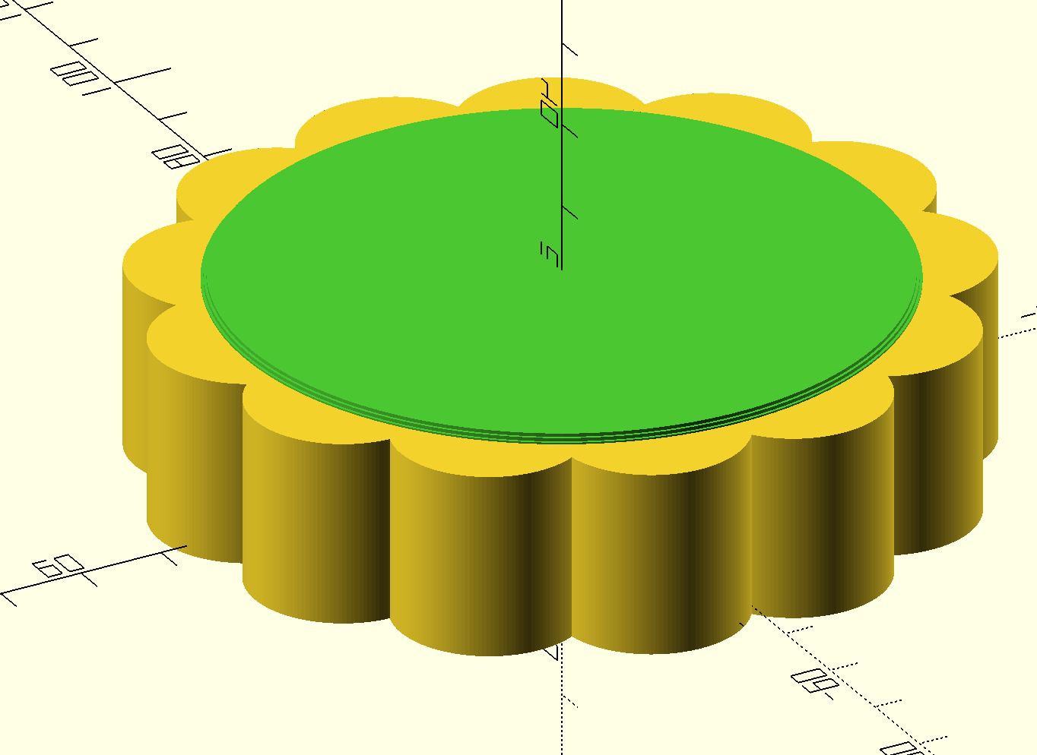

The green part is created by code.

Step 4: TaiJi patten

This is the most complicated part of this project. We need to use multiple Boolean operations such as difference, intersection The design of Tai chi patterns needs to go through the following stages:

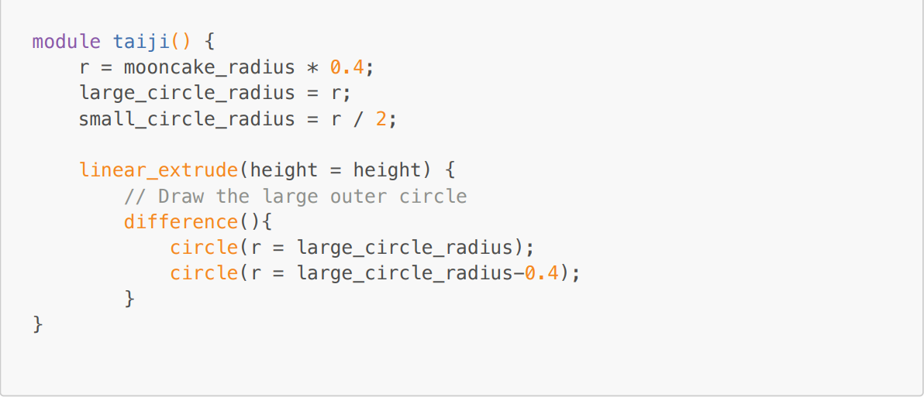

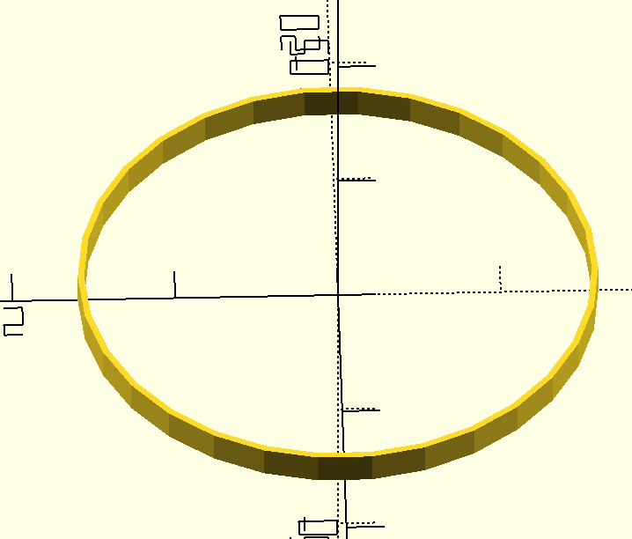

Seeing the patten of TaiJi, we can protrate that TaiJI symbol as: a union of a large circle and a semicircle, unioned with a small circle whose radius is half the radius of the large circle, and then differenced with the other half of the large circle. Thus, we can convert the task into three: 2.1: Creating the main half circle; 2.2 union or difference two small circle.

2.1 Main half circle

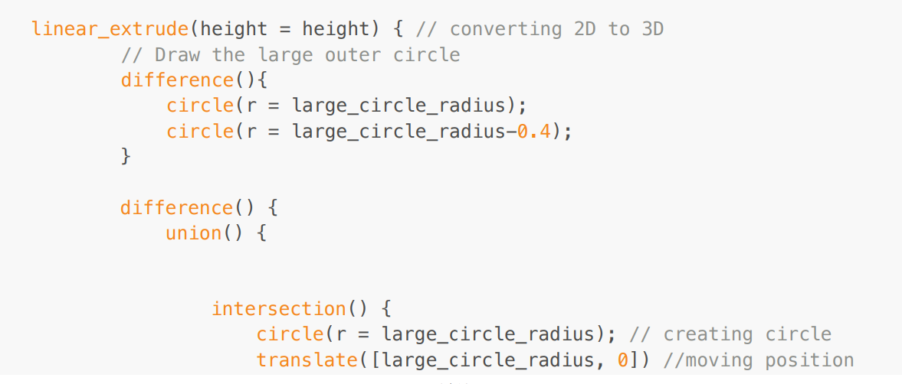

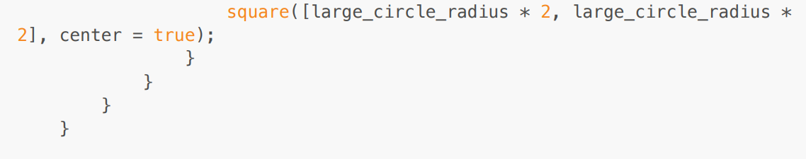

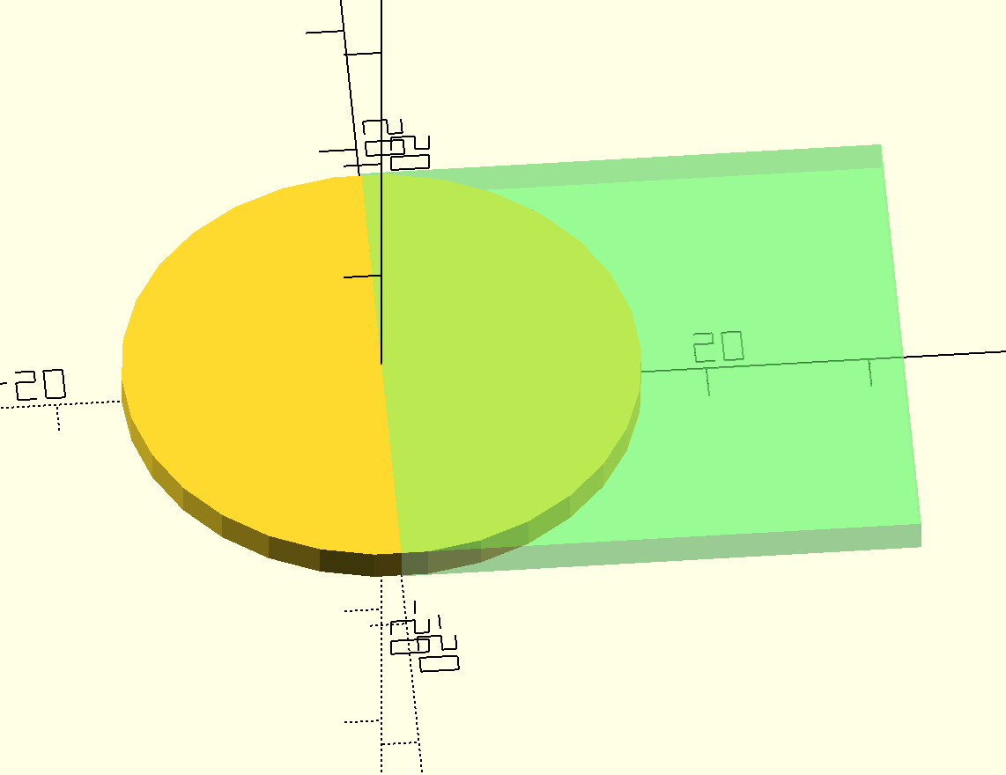

As code and graph demonstrate, the half circle is created by intersecting a circle and a square on circles' one side. 2.2 union or difference between two small circles. Similarly, we can create two little half circles, but one is Union to the main half circle another is Difference.

Thus, we can get the final image demonstration and code:

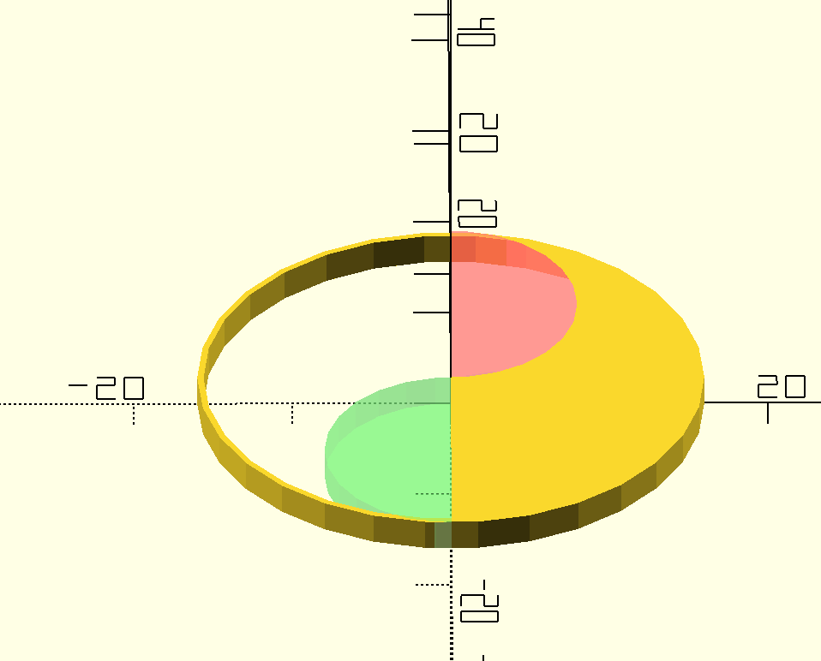

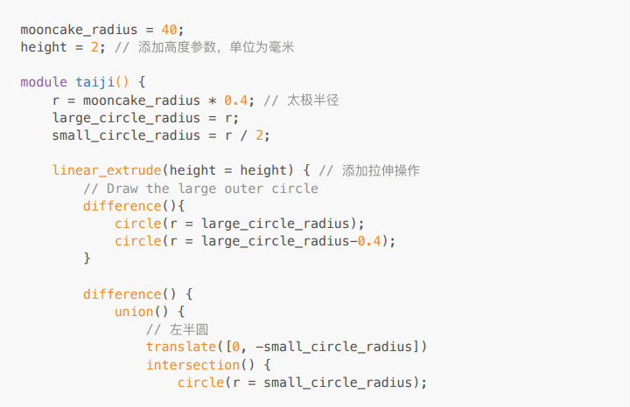

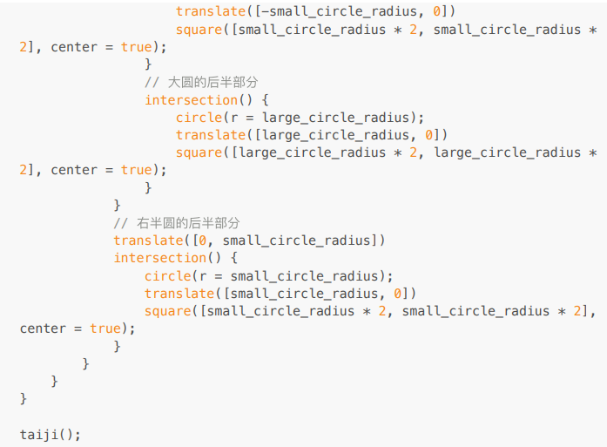

Step 4: Finish Up

After adding some text on it, we can get the finally code.

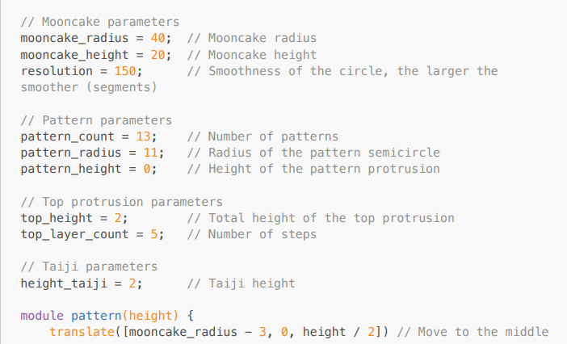

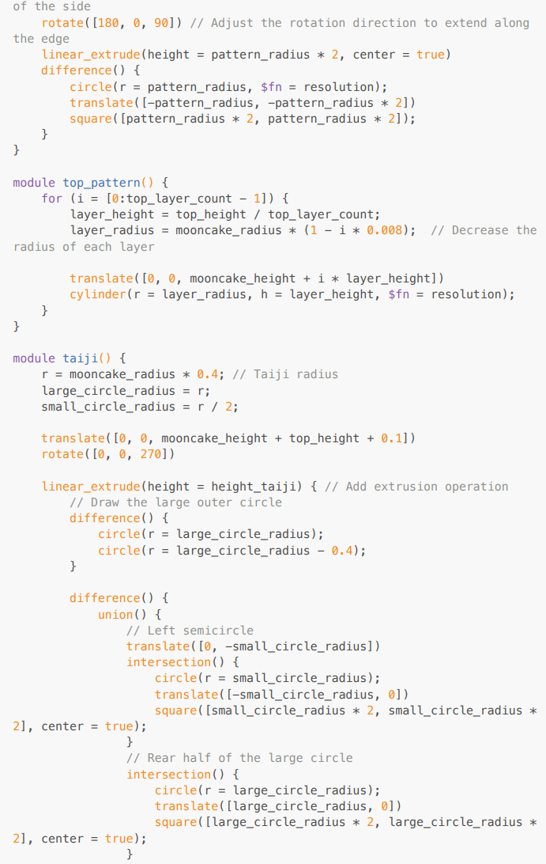

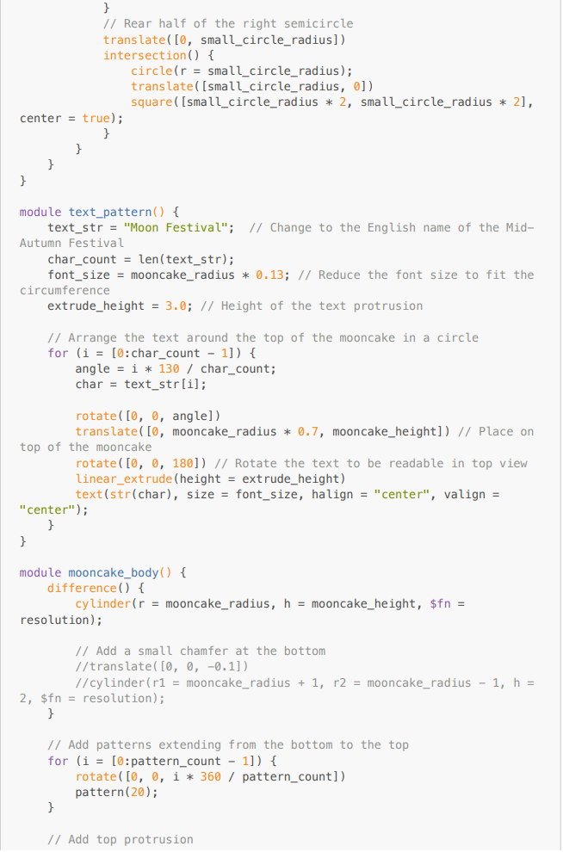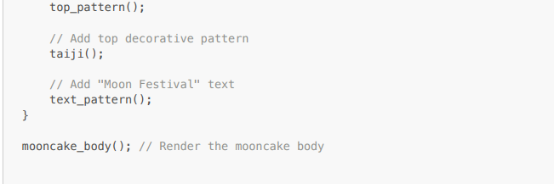

After render， we can get this image about mooncake:

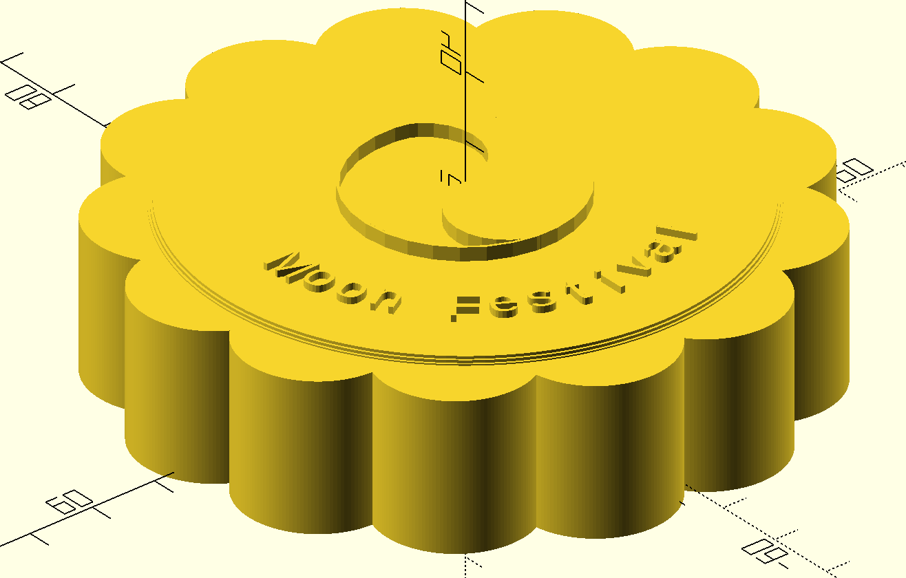

Author(both for this document and model creating)：Tony Wayne Wang

**Rendering**

**Step 1: Create project framework**

In order to put the models into an animated, rendered 3D scene, the WebGL-based library, THREE.js was used. To start the project, first I composed a simple HTML file that loads in the main THREE.js javascript codes from the file main.js, so that it may be displayed on a browser page:

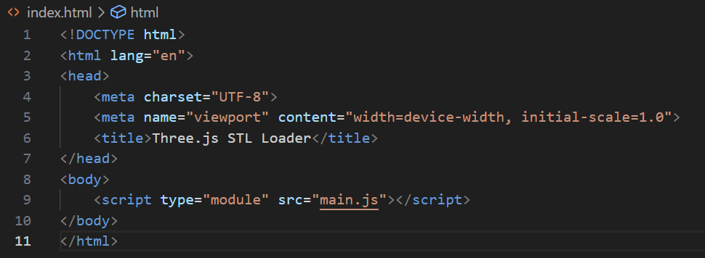

**Step 2: THREE.js scene initialization**

As THREE.js is an external 3D library for the coding language javascript, we start first by creating a javascript file and importing the necessary libraries:

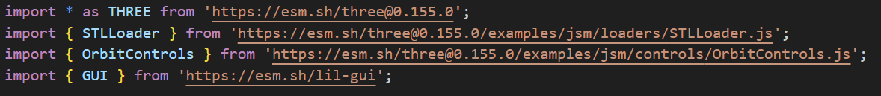

Then, we initialize essential components for our rendering, which include the scene, renderer, ambient/point lighting, variables, and texture resources. A few lines of the texture initialization can be seen marked off as comments as the resource they load in are UV checkers that won’t be present in the final rendering.

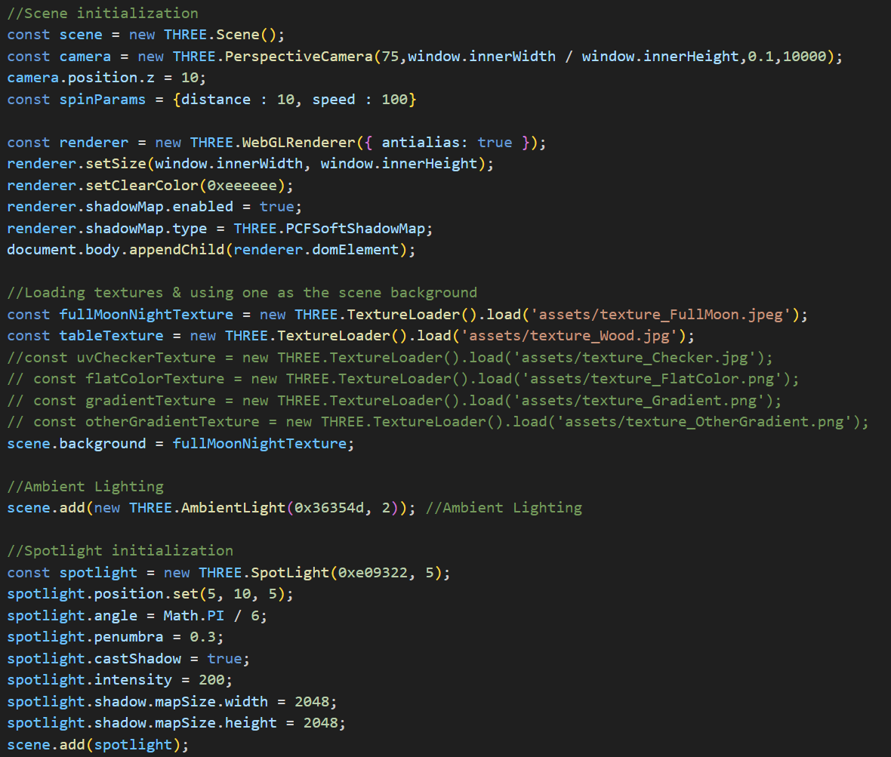

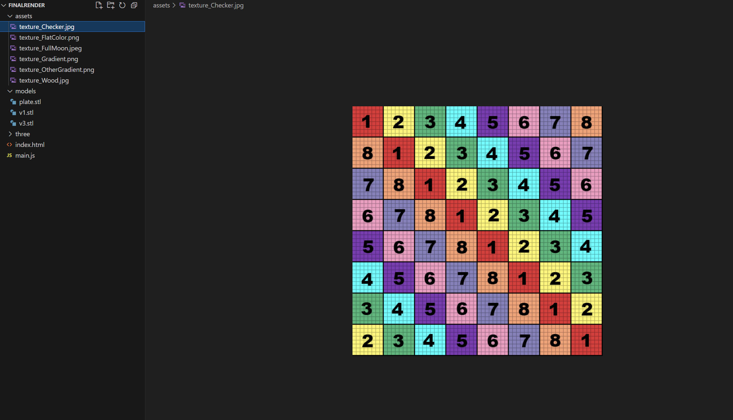

UV Checker Texture example

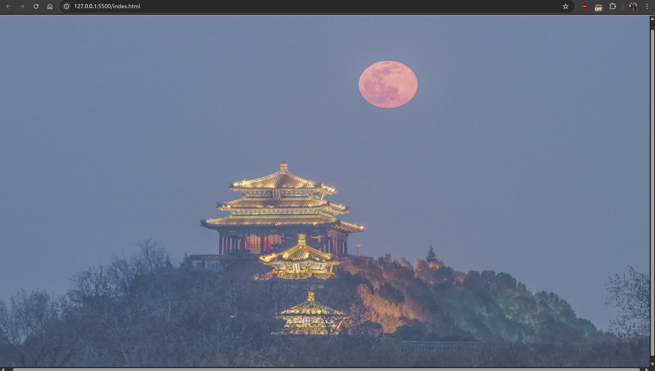

Initialized scene without models

**Step 3: Adding models/geometries to the new scene**

Now with the scene initialized, we write code to add 3D objects into the scene. The code below showcases the initialization of both the table and 3 mooncakes.

-Notice that the table’s initialization did not involve using STLLoader, that’s because the THREE.js library offers built-in functions for initializing simple geometries, which is enough to support adding a box-shaped table.

-For the code initializing the mooncake models, a for loop is used to load in multiple of the same model while keeping the code compact.

-The mooncakes’ material does not have a texture map due the STL models not having working UVs. Efforts to apply the texture checker to the models reveal that they seem to be only reading a single pixel from the textures, which give the models a solid color instead of any desired patterns.

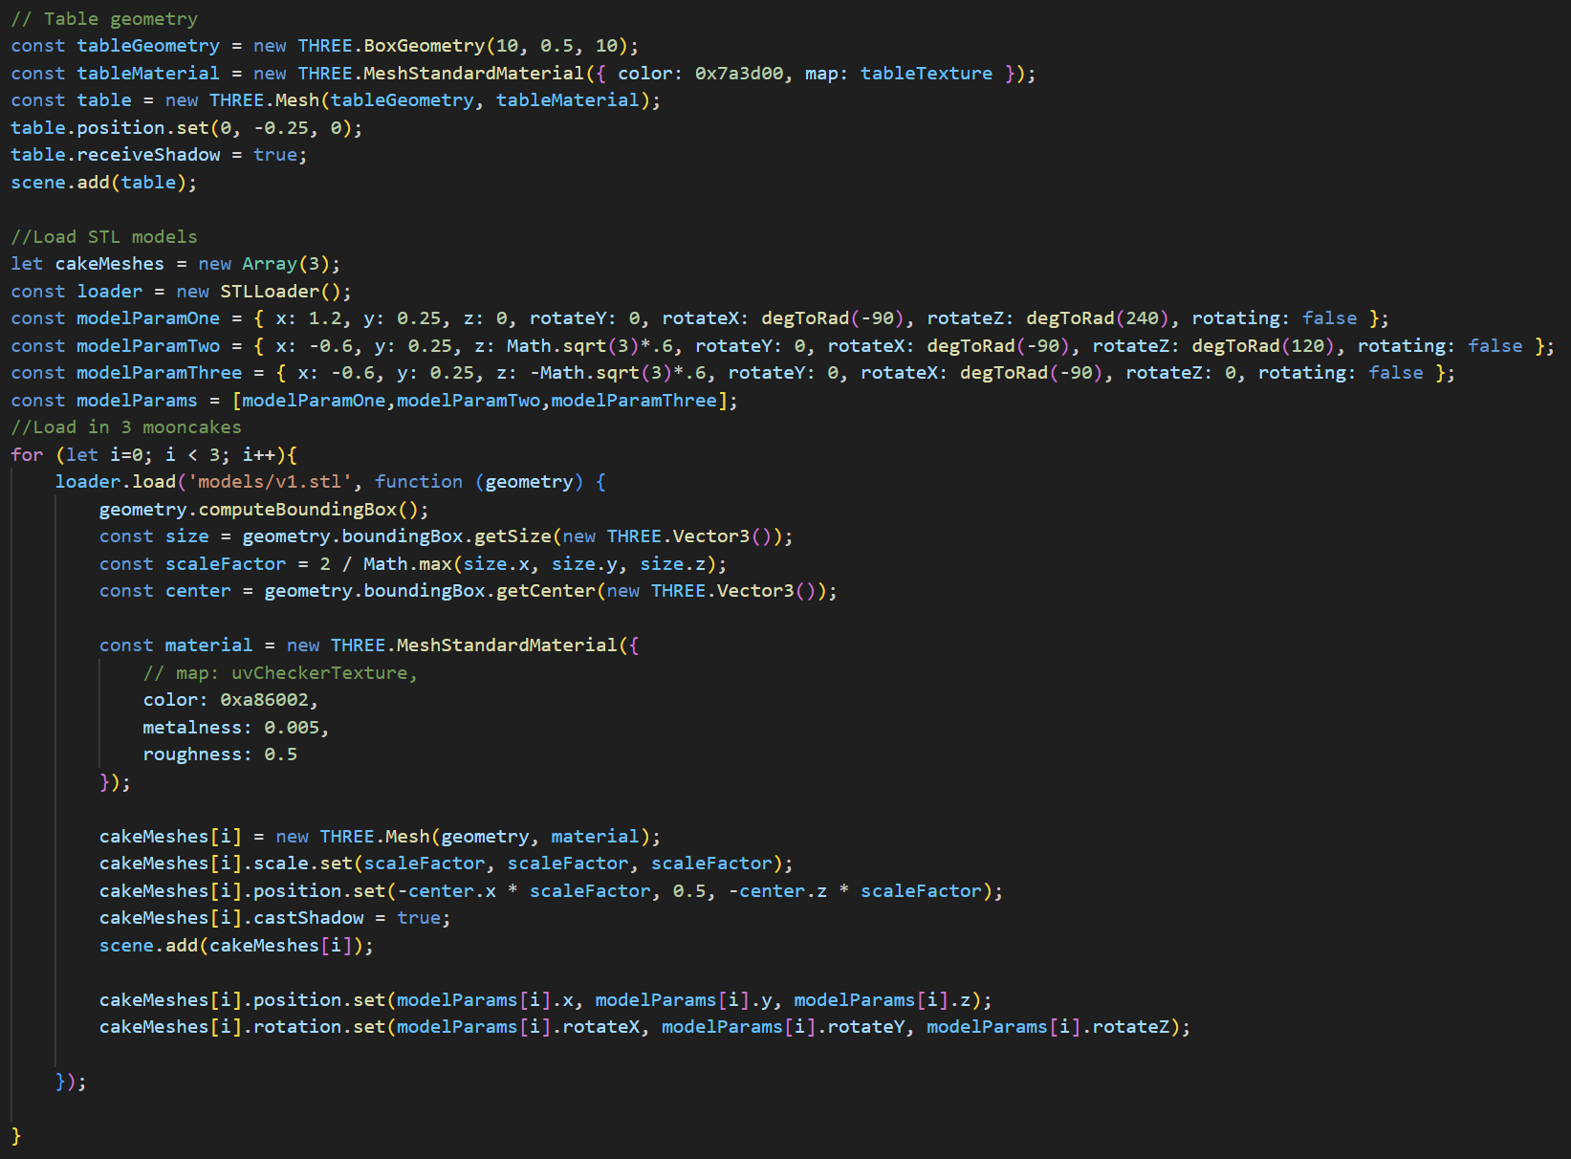

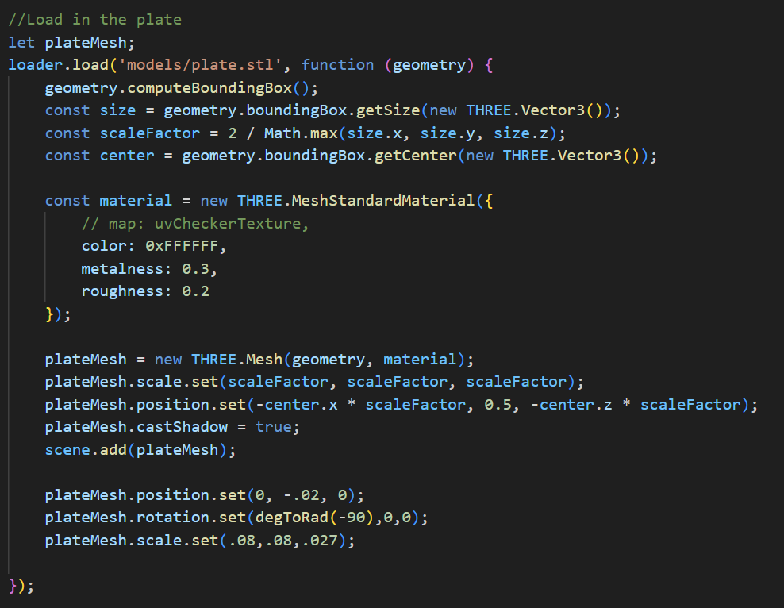

Loading in the plate, scale manipulation is used on top of position and rotation to make the plate the desired size, eliminating the need of doing so in the modeling process.

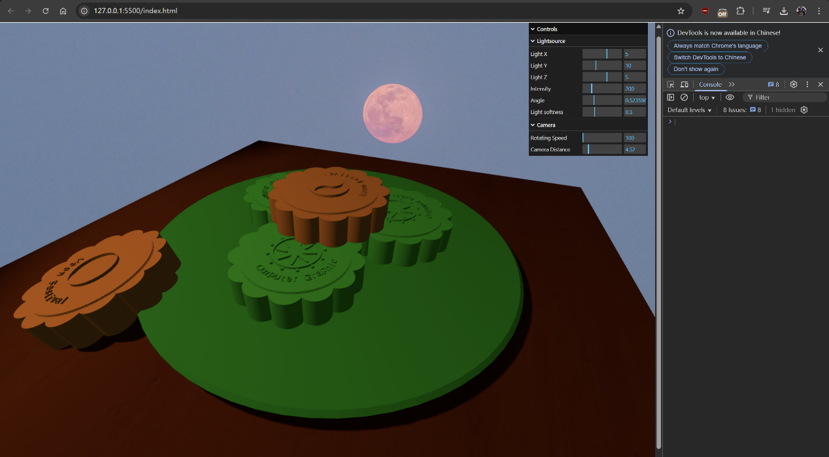

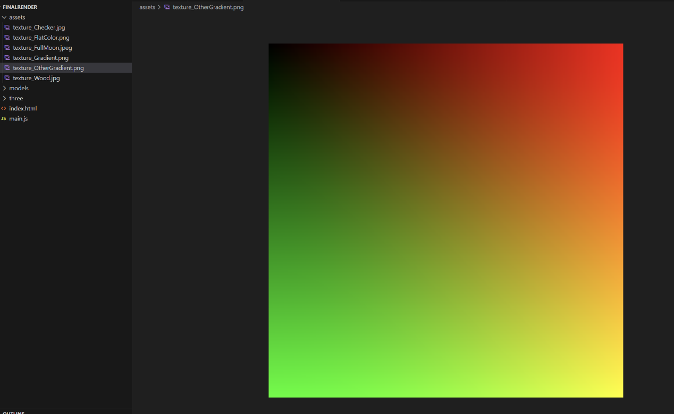

Example of a gradient texture being applied to the STL models. As it shows here, the pattern is not visible due to the models’ UVs not supporting it.

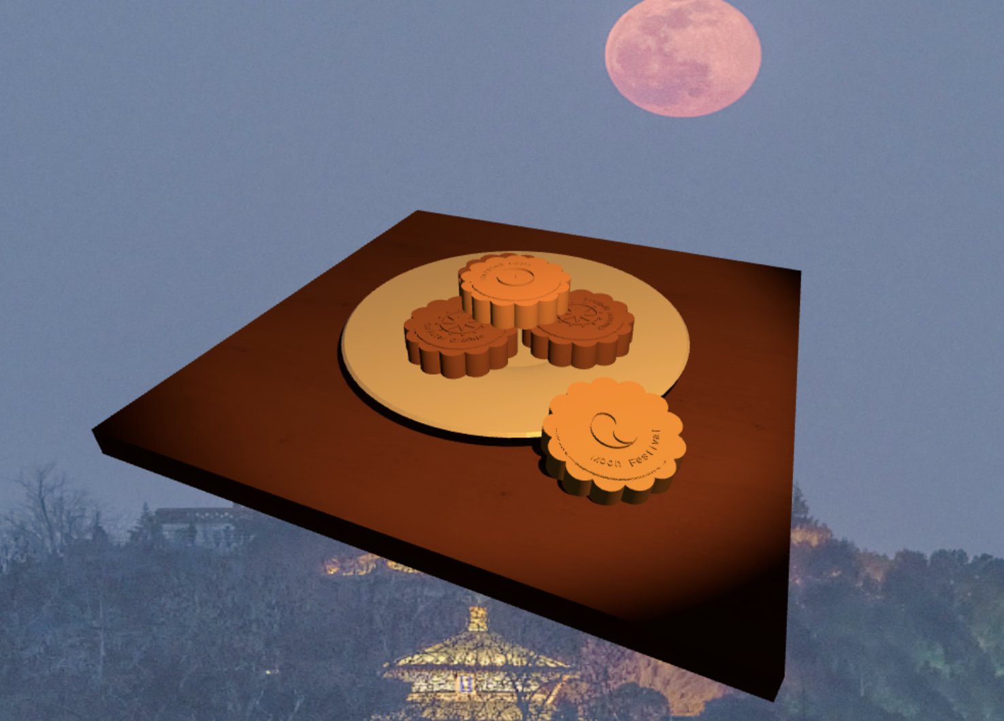

Scene with models loaded

**Step 4: Adding Particle Effect and its GUI**

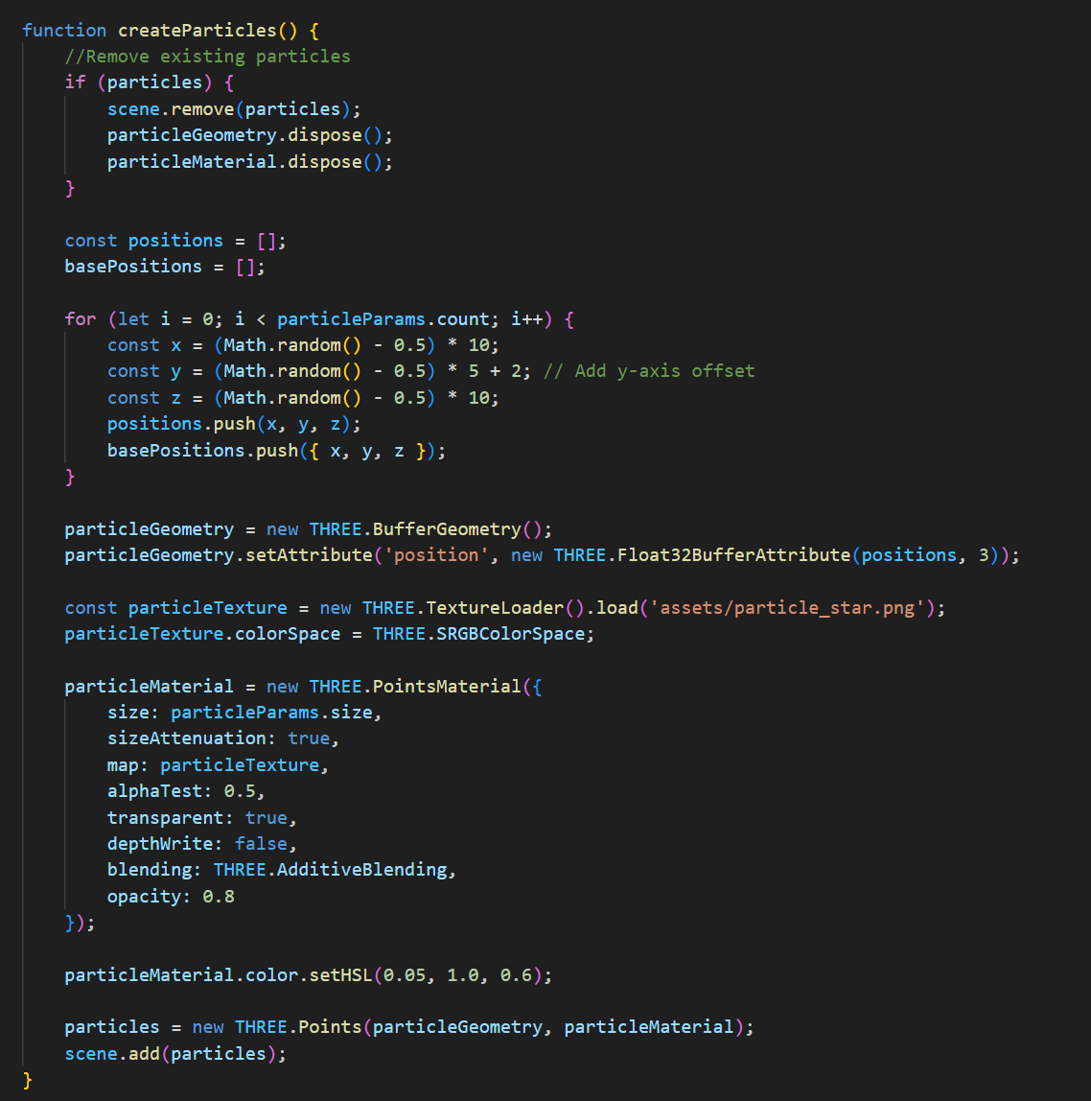

This function load the particle assets so that they popped in the scene with certain parameters like popping position and their random height to make it look natural.

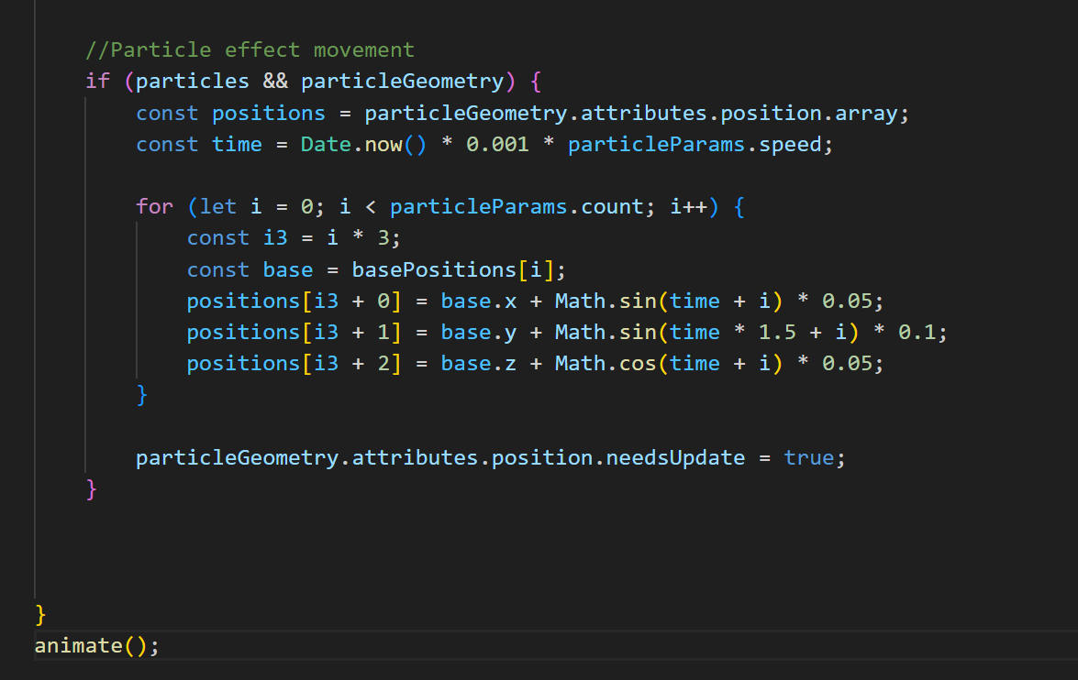

Trigonometry function is used here to better simulate the floating movement periodically.

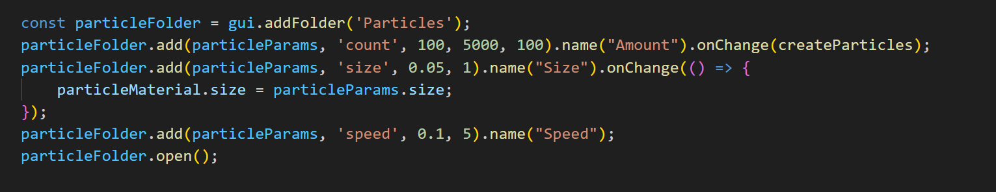

This block of code is for creating the GUI that let users play with the particles like changing their floating speed, density and size.

**Step 5: Making the turntable animation & other features**

To animate the scene, a simple function rotate Cam() is written to change the camera’s X and Z position in relation to the sine and cosine of the current time, effectively creating a turntable effect.

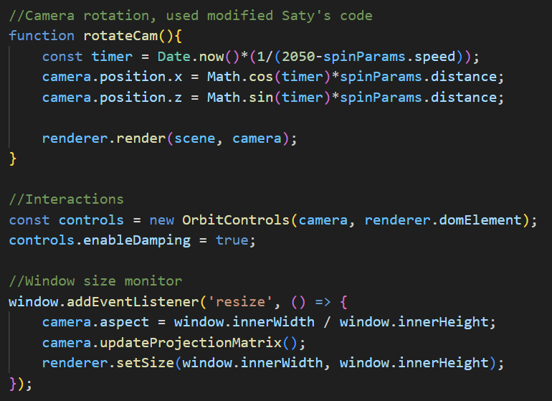

Then, this function is added to the animate() function, executed every update:

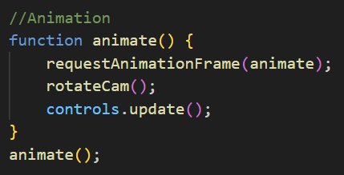

Lastly, a GUI for the user to change the scene parameters on the fly is added, making the scene interactable and allowing for dynamic manipulation of its presentation:

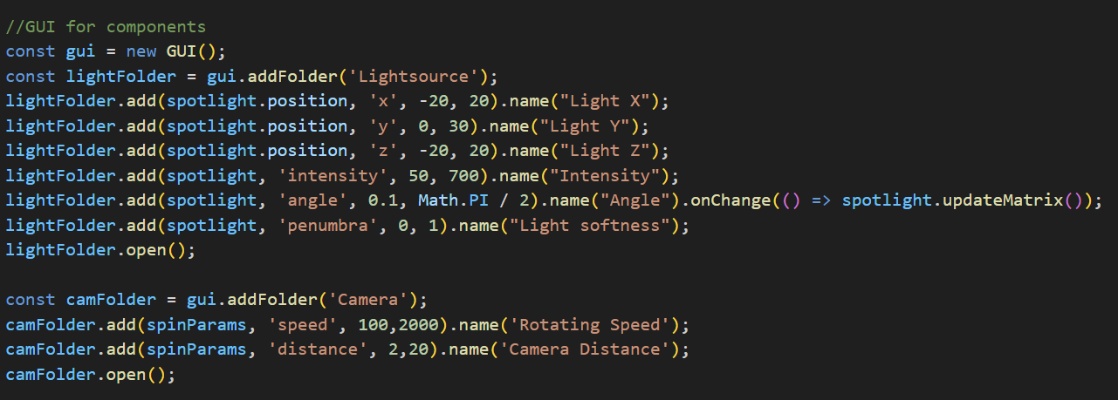

The scene at this stage presents as follows, with parameters altered using the GUI controls: